# A Slice of the Big Apple

I just returned from a SUUUPER fun weekend with my daughter, Amber, in New York City. We flew up there last Thursday and although we battled canceled flights and significantly delayed flights (due to Winter Storm Oakley), we both made it to our hotel safely and met up with each other there.

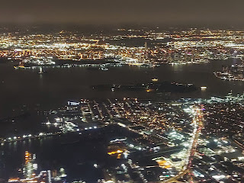

Amber arrived several hours ahead of me, and was brave enough to make her way from LaGuardia Airport to our hotel in Manhattan by SUBWAY and BUS!! Since I arrived quite late, around 10:00 p.m. EST, I opted to pay the exorbitant taxi cab fees ($53) to go directly to the hotel. I didn't want to be traveling alone so late at night on any other mode of transportation. Not in NYC!!

Click to see the view as we flew in over Manhattan: (28 seconds)

https://photos.app.goo.gl/RZ9DLdjqvnLhMRB29

When I left Idaho, it was roughly zero degrees at 6:30 a.m. I drove down to Salt Lake City and arrived in plenty of time to park my car and catch a shuttle over to the airport. My flight left on time and made good time down to Houston, where I had an hour layover and changed planes.

View over Salt Lake City and nearby mountains -

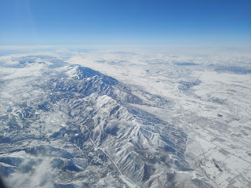

View of the sunset from Houston . . .

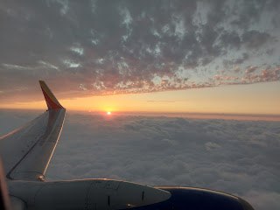

While my flight from Houston was delayed by about 1.5 hours, Amber was lucky to have made it to NYC by the skin of her teeth! As she left early from Louisiana around 6:00 a.m. to drive to Dallas (3 hours west), Winter Storm Oakley was bearing down and causing all sorts of ruckus on the roads. There were so many slide-offs on a section of I-20 West that Google told her to get off the interstate and take an alternate route. She called me several times and described how the road was so icy that she kept fishtailing and while I was talking to her she even slid past an intersection where she needed to turn. She was out on some narrow county roads and they were even more slick than the freeway. We were convinced that she wasn't going to make her original flight, so Weston started working on a backup plan for her from home. But she miraculously made it in time for her flight and got on with just enough time to even go potty! She had a connection in St. Louis, and then made it on to NYC from there. Whew! What a relief!!

I landed in NYC around 10:00 p.m. and after securing my luggage, I hopped into a yellow taxi and told him the address of the hotel: POD Times Square, 400 W. 42nd Street. I sat behind a plexiglass window that also had an I-pad playing numerous ads and news bits. I wish I had figured out sooner how to turn the volume down . . . My driver was from Bangladesh and has been married since 1982! He was on the phone doing his own business with a bank for most of the drive, but we did chat a little near the end. This was my first experience with how NYC taxi drivers loooove to lay on the horn.

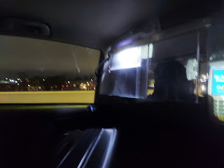

View of one of the many bridges from the backseat of the taxi

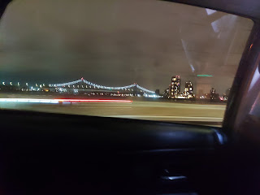

At a red light, I delighted in seeing someone buying a hot dog from a street vendor.

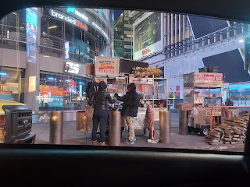

Once I got to the hotel, Amber and I chatted about our travels and experiences of the day until well after midnight, when we decided we had better go to bed. Our hotel room was super cute and had a great view from the 9th floor. The room was just perfect for the two of us, complete with two twin-sized bunkbeds, along with a shower and bathroom area.

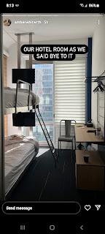

It took me quite a while to quiet my brain and actually go to sleep. I think I fell asleep around 2:00 a.m. and woke up many times before giving up around 6:30 or 7:00 a.m.

Friday:

We showered and got ready and then headed out to see what we could see. Amber had already secured a Metro card the day before, but I needed one for myself so we could get around. There are machines at each station that are similar to an ATM, where you can purchase a card and put a designated amount of money on it. On average, we spent about $15/day using the subway system. Each time you go underground and through the turnstile, you are charged $2.75. It was very convenient to reload our Metro cards when needed.

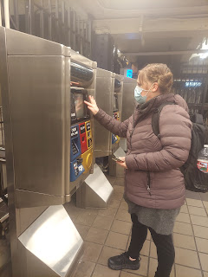

Friday morning was quite cold, with fresh snow, slush and ice on the ground everywhere. The trees and branches were even coated in ice. Several times I saw what looked like pieces of paper floating down from the sky, but it was just a sheet of ice falling from somewhere above, shattering into tiny bits on the street or sidewalk as it landed.

It was rainy for most of the morning, causing a hypnotizingly beautiful fog that enveloped all the skyscrapers, and which also created a beautiful photo opportunity.

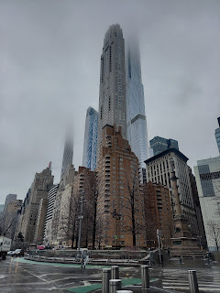

We took the subway up to 59th St/Columbus Ave so that Amber could find a pair of shoes at the Time Warner Fleet Feet store. It felt amazing to be walking down the streets of New York City together.

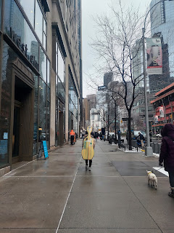

Inside the Time Warner Center, there were several floors and shops, like a huge indoor mall. We thought some of the art was quite entertaining.

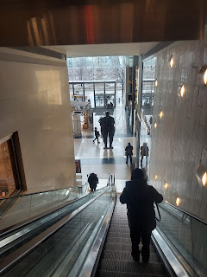

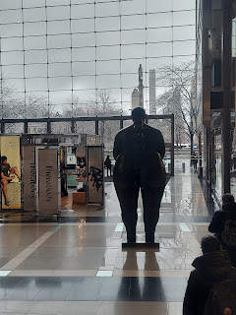

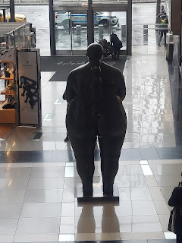

We found a darling children's store called CAMP. It's loaded with books, toys, and all varieties of educational tools, along with areas to play and enjoy. Like this huge sequin-lined fort to "draw" and create a masterpiece.

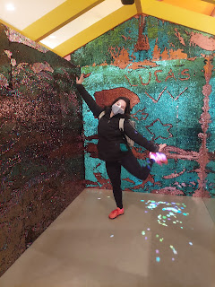

Or this mini racetrack to ride around on . . .

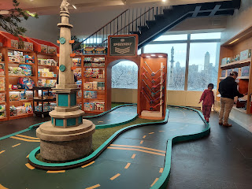

Eventually we found the Fleet Feet store, also known as the NY Running Store. They did an arch analysis for my feet, to help me find the best arch support and hopefully put an end to my plantar fasciitis issues. I stepped on this board, and my feet left a heat imprint so they could see exactly what my arch height is. Then they helped me find the best set of insoles to put into my most recent purchase of walking shoes. Awesome!

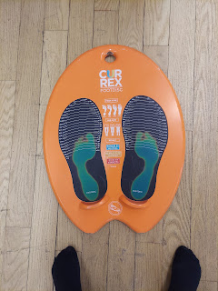

Meanwhile, Amber had her gait analyzed by running on the treadmill while her feet were recorded on video to see how they strike with each step. She ended up getting a pair of insoles as well, instead of buying a whole new pair of running shoes. By the way, they do the analyzing for free. How nice!

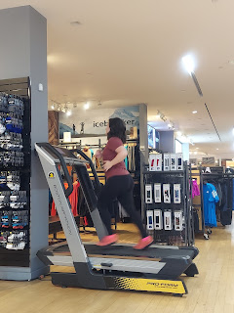

After getting a bite to eat inside the Time Warner Center, we headed back out into the sleet to explore Central Park a little bit, since it was right across the street.

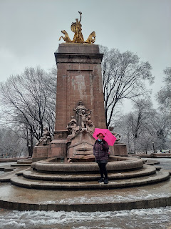

We met two young ladies from France (cousins), and after we offered to photograph them on this charming bridge, they took some pictures of us as well. As we were getting "set up" for the photo, Amber's umbrella got stuck in her hair momentarily, which made us laugh. I didn't know that the girl from France was taking pictures of that until later . . . ha ha.

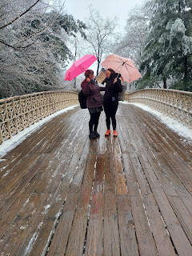

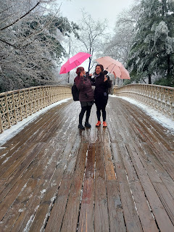

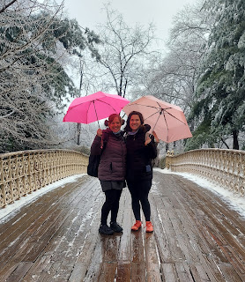

You can see some of the skyscrapers through the trees of Central Park.

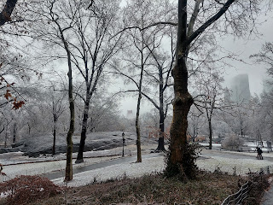

Closer to our hotel, and after we dropped off our shopping loot, we found a slice of pizza at Two Bros. It was fun to watch the one guy making a new pizza crust every

minute

- he was so fast!

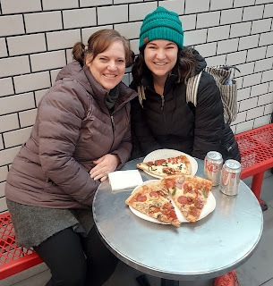

Click to watch the pizza whiz guy: (19 seconds)

https://photos.app.goo.gl/xTzaZbgEGLPG3nHL8

From there, we hopped on the subway again to head over to MOMA - the Museum of Modern Art. Amber was the brains of the subway operation each time. She had an app on her phone to help us navigate, and I would help pick out the signs above us to correspond to what she was seeing on the app. We made a great team. :)

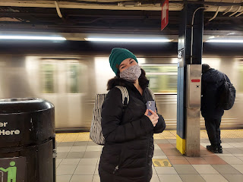

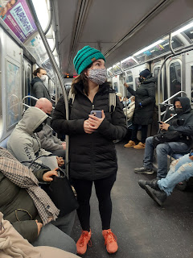

*Important Tip if you're planning a trip to NYC:

Get the City Pass

. We bought ours from this website:

https://gocity.com/new-york/en-us/products/explorer

It's called the New York Pass by Go City. First, we made a list of all the places we wanted to see. Then I looked at each website to see how much it would cost us to get in if all we did was pay for each venue individually. It would have cost us $279 each (MOMA, St. Patrick's Cathedral, Empire State Building, Rockefeller Center - Top of the Rock, 9/11 Memorial & Museum, Harbor Cruise, Central Park Bike Rental and the Hop On Hop Off Bus). But by purchasing the City Pass, we only paid $179 each, so we saved $100 each. All we had to do was pull up the Pass on our phone and they would scan the QR code and then we could enter. In some instances, we had to exchange our QR code (City Pass) for an actual ticket to get in. But it didn't cost us anything to do that. It was very convenient for everything we ended up doing. (We didn't end up doing the Hop On/Hop Off Bus or the bike rental in Central Park, but we did everything else.)

*Also - we brought our vaccine cards with us because without them, we wouldn't have been able to enter 90% of the places we had on our list, including eating indoors at a restaurant. At each venue, we would show the City Pass, our vaccine card, and a photo ID.

Inside MOMA, we found so many beautiful pieces of art!! From Picasso  . . .

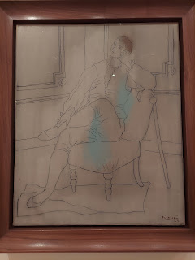

To Claude Monet . . .

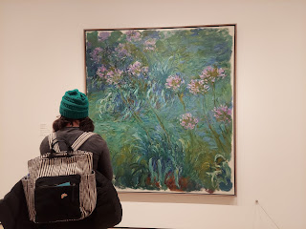

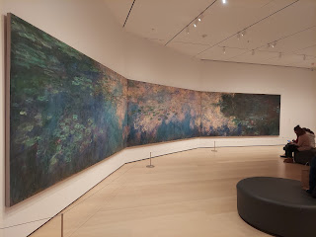

To many, many others . . . I particularly enjoyed this painting of a doctor.

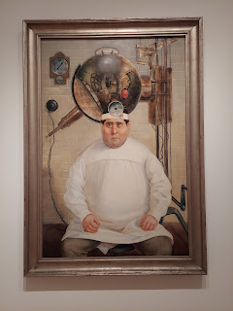

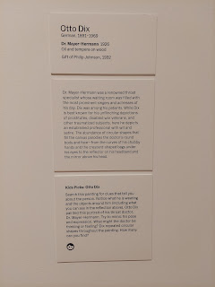

These next 3 pieces are actually stamps that were made from woodcut art. They are very emotional pieces, depicting the anguish and pain from World War I from a German artist's perspective.

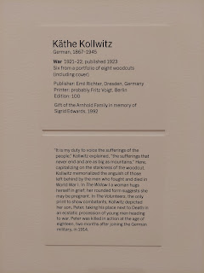

"The Parents"

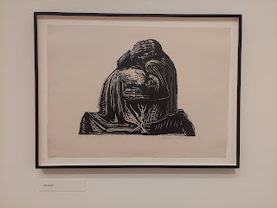

"The Widow" (also pregnant)

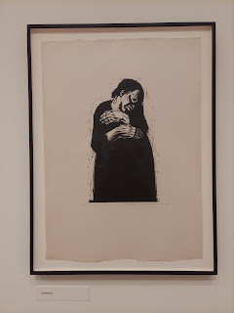

"The Mothers" (I especially loved this one)

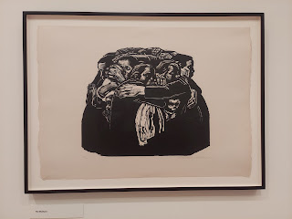

I didn't take a picture of who this artist was . . . sorry! But I liked the imagery. Very whimsical.

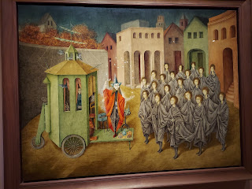

This intricate wood-carved piece depicts Adam and Eve in the Garden of Eden.

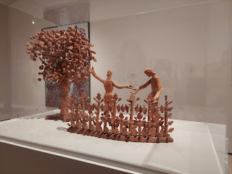

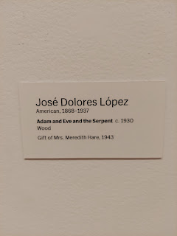

We even found Henri Matisse . . .

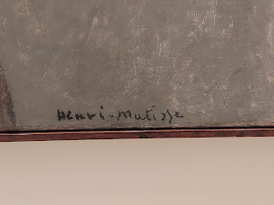

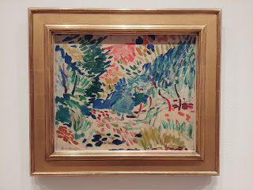

I loved seeing the joy that Amber got in wandering from room to room and taking it all in.

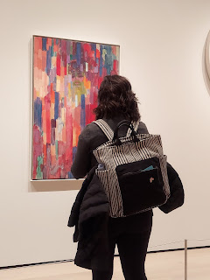

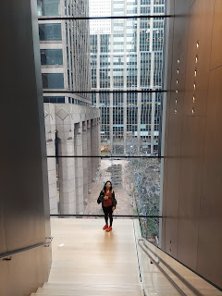

Look closely at these next 2 paintings . . .

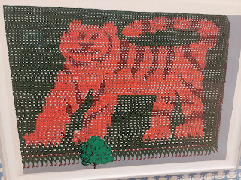

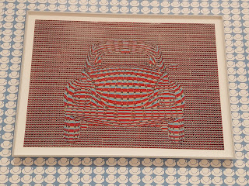

When we arrived at this exhibit, Amber was instantly moved to tears.  She connected this piece in her heart to the people of Ukraine, currently suffering from the effects of war that is ravaging their beloved homeland.

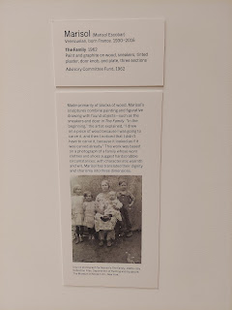

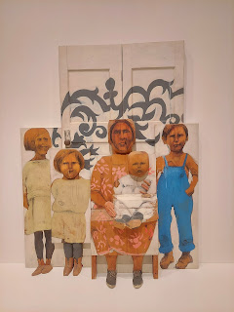

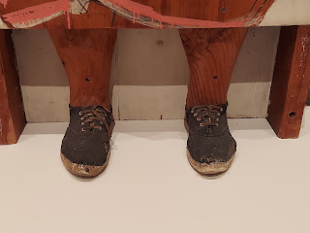

What a wonderful afternoon at MOMA!

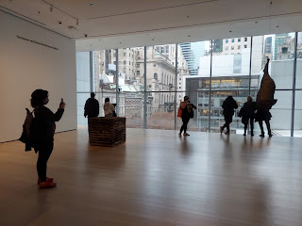

Next, we headed over to see Amber's art in the Center Gallery, the whole reason we came to NYC in the first place! But as we came up out of the subway, seeing the Manhattan Temple took our breath away! We were not expecting to see this at all, and it's right next to the Center Gallery!!

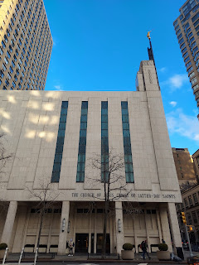

We went inside the main entrance, to inquire if there was a visitor's center to browse. There was not, but the lady working at the desk told us we could take the elevator up to the 3rd floor and see some beautiful art on the walls of the hallway up there. Great! Let's go!

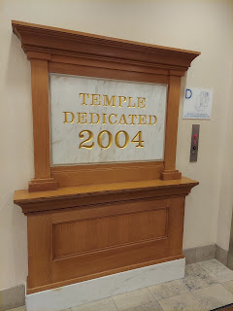

I think all of the art that we saw upstairs was all done by Walter Rane. Simply stunning. Oh, by the way, the 3rd floor was an actual meetinghouse where congregations meet on Sundays for church! (More on that later) It looked just like any other LDS Church building, with a cultural hall (gym), classrooms, a chapel, bathrooms, and a kitchen.

"They Saw the Heavens Open" - 3 Nephi 17:24 when Jesus came to visit the Americas and blessed the little children.

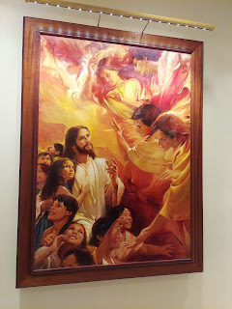

"I Even Remain Alone" - Mormon 8:3 when Moroni is left to finish writing about the destruction of his people somewhere in North, Central, or South America in roughly A.D. 400-421.

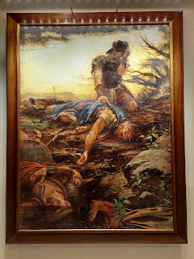

"His Father Rejoiced" - Mosiah 27:20 when Alma the Younger was scolded by an angel for seeking to destroy Christ's church, fainted, and had to be carried home. His father's prayers were answered that the angel came to intervene, and after repenting, Alma the Younger later became an amazing missionary and prophet.

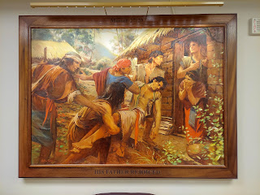

"Come Forth" - Alma 46:20. Captain Moroni declaring a passionate motto of defending their lands, their freedoms, their wives and children, and calling the people into action to join the great cause of liberty.

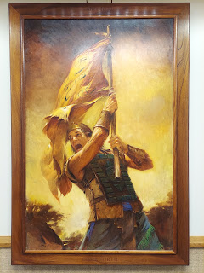

"He Did Bring Glad Tidings to my Soul" - Helaman 13:7. An angel came to Samuel the Lamanite to encourage and instruct him on what to say to the wicked people a few years before Jesus was born.

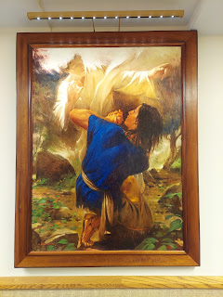

After oohing and aahing at all the beautiful paintings in the Manhattan Temple (technically the 3rd floor meetinghouse, not the actual temple itself), we walked next door to the Center Gallery. We hugged for a good long minute outside the door, rejoicing in actually being here in this moment, and then we went inside.

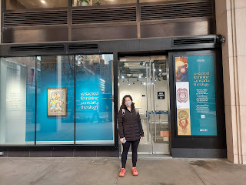

Right inside the front window is the most detailed beadwork painting I've ever seen. This is all made from thousands of tiny little beads that were most likely glued on.

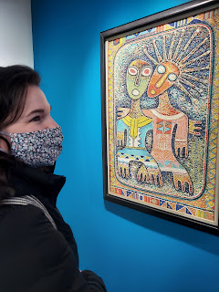

The whole exhibit was focused on the Sacred Feminine and Divine, with artists' interpretations of Heavenly Mother for the most part.

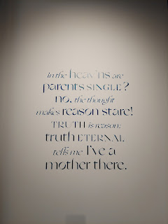

In the interest of time and getting this blog done a little faster, I will just share a link to all the photos that I took in the Gallery. While Amber was visiting with the Gallery director, Glenn, I went around and took pictures of everything.

Amber - standing in front of her painting of Heavenly Mother. 💓

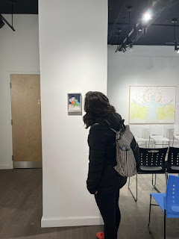

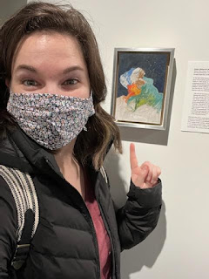

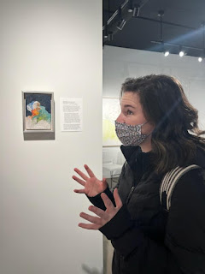

Here is a video tour of the Gallery: (1 min, 23 seconds)

https://photos.app.goo.gl/LNBCcn1jWijmvG4i8

And here is the link to the photo album with everything:

https://photos.app.goo.gl/RrNju1YwWVvHvvKg8

You'll see all the exhibits with descriptions of each. You'll also see photos of Amber visiting with a couple of visitors that came into the gallery while we were there. In addition, there was an ensemble concert that evening that we came back for. It was a group of  5 young musicians, including a flute, 2 clarinets, a bassoon, and a French horn. After the concert, Amber signed the guest book and shared some beautiful and sweet thoughts.

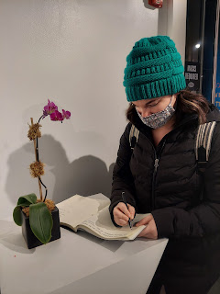

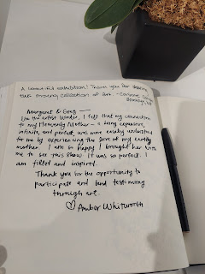

What an amazing thing - to travel to New York to see my daughter's art on display in a gallery right next to the Manhattan Temple!! Wow. I am just so proud of her and I'm in awe of her accomplishments, each one at a time. She is honing in on her potential, and realizing that what she has to say and share is so uplifting and encouraging to the world. Through her art, she lifts people up and inspires them. When she adds her thoughts and feelings to her art, our depth of understanding is exponentially increased. My heart always bursts with love and joy when she creates each new masterpiece to share with the world (and me).

In between seeing the Center Gallery exhibits and attending the concert, we walked a few blocks away to a cute restaurant named "Amber".

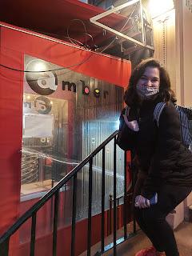

We ordered chicken satay, duck spring rolls, and sushi (one of her all-time favorites).

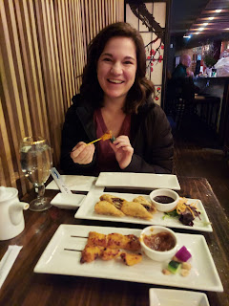

After we finished hanging out at the Center Gallery, we took the subway back to our neck of the woods on 42nd Street. Times Square just happens to be right there as well.

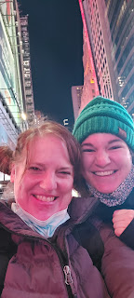

Video of Times Square: (26 seconds)

https://photos.app.goo.gl/3mnuDchWQYABmJYp6

To me, it was just another intersection with lots of lights and people. But the next night, they blocked off some of the traffic flow to accommodate a musical event of some sort and it was definitely a more exciting vibe. We found out later that it was a rally of sorts to show support to the Ukrainians. I wish we had stayed a little longer! I suppose it's a lot more exciting to be there on New Year's Eve, too . . .

Each time we go underground, there is always a new and interesting musical flavor in the subway. Here are some of the artists I captured.

#1: A John Lennon fan (28 seconds)

https://photos.app.goo.gl/ceLDWjeZR9fgfZS18

#2: A group from Brazil (51 seconds) (They were really good and I also threw some $$ in their suitcase)

https://photos.app.goo.gl/zzkb7ogdGW11h4tj6

#3: My personal favorite - the Latino Dancer with his skeleton dance partner (17 seconds)

https://photos.app.goo.gl/AWrvibuDnJARgKsp7

Saturday:

We got a better night of sleep on Friday night, so we were in a much better position to get up and going early on Saturday.

Soon after exiting the subway station near 50th Street, we saw a man pushing a very loaded cart along, when all of a sudden one of the wheels underneath the cart came off. The cart almost tipped over but thankfully the man was able to hold it up. A couple people came running over to help, including Amber! While the others supported the cart above, Amber retrieved the missing wheel and plugged it back into place underneath. A real NYC hero!! :)

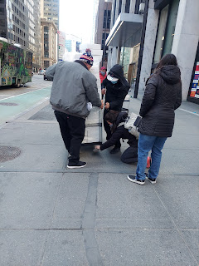

There's a really cool place where kids can learn all about the NY Fire Dept. and even climb into a firetruck indoors! It was close to Rockefeller Center, in case anyone is interested. (61 W. 48th St) Amber wants to bring her family to NYC next time, and she plans to let the girls visit this fun little shop.

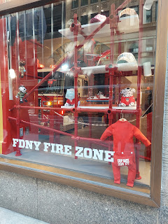

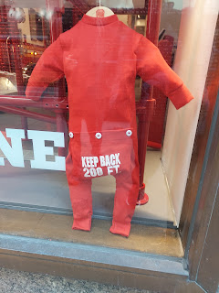

Rockefeller Center is so cool! We absolutely loved this area. There is the famous ice skating rink across the street from the Rock (the building itself).

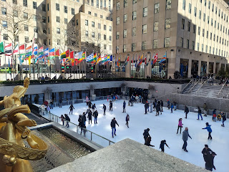

Short video of the skaters: (15 seconds)

https://photos.app.goo.gl/g1acgV7Qhg2r5yFbA

Flags from all around the world are on display in the Rockefeller Center Plaza.

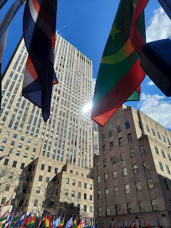

Time to go up.

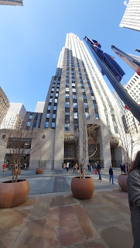

John D. Rockefeller did a lot to help the everyday people during the Great Depression.

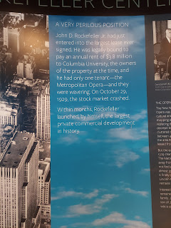

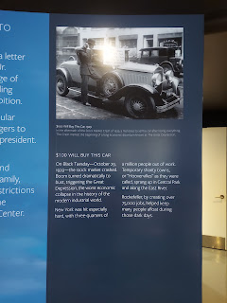

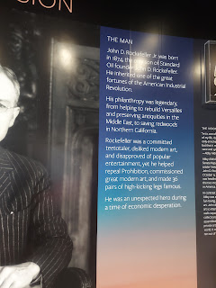

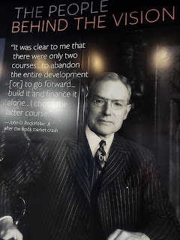

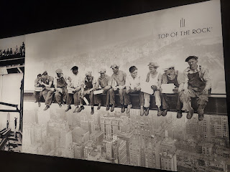

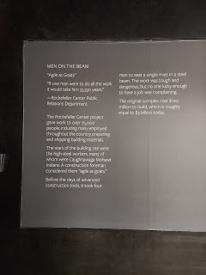

The view from "Top of the Rock"

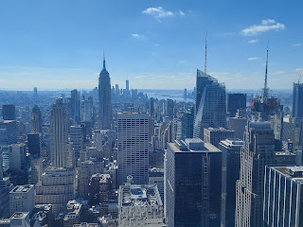

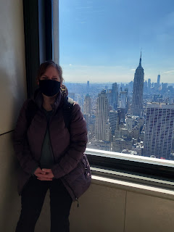

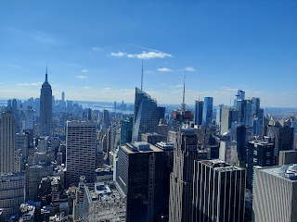

Looking down from this side, you can see St. Patrick's Cathedral below. That would end up being our next big stop.

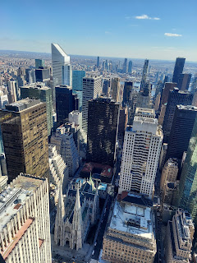

Short video from the Top of the Rock: (16 seconds)

https://photos.app.goo.gl/zXveZXPeXWLdy4Qc7

St. Patrick's Cathedral (Catholic). Built in 1878, it is the seat of the Archbishop of New York.

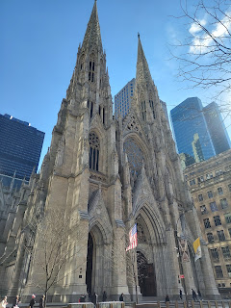

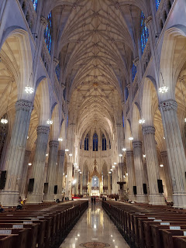

Short video of the same interior view, but more expansive overall: (24 seconds)

https://photos.app.goo.gl/a4wmtZ12M7TazGPN6

I loved the tribute they gave to Mother Theresa of Calcutta.

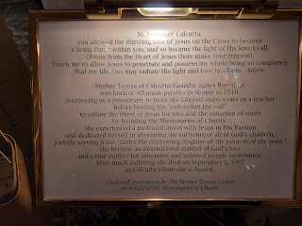

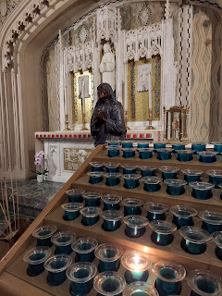

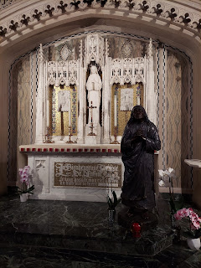

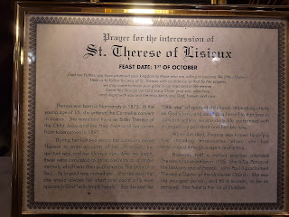

Such a tender scene depicting Mary and her son, Jesus. It drew me in and I just had to touch His feet. When I touched His foot it was very cold and surprised me at first, but I quickly realized it was merely because it was made of marble.

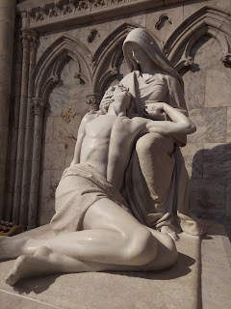

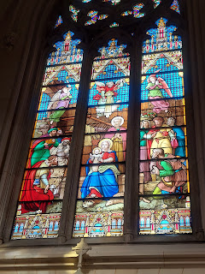

After we slowly and reverently made our way around the Cathedral, we walked down the street to revisit a store we saw on our way to the Rock. It's right next door to the Rock, and is a famous toy store called FAO Schwarz. It is the oldest toy store in the U.S., having first opened its doors in 1862 in Baltimore. A few years later the headquarters was established in NYC and it has the most amazing and educational toys inside!!

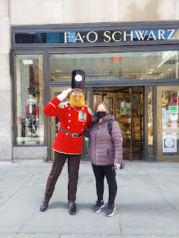

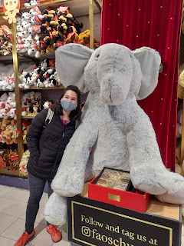

They have the SOFTEST stuffed animals you've ever touched, and quite a charming array of other stuffed "things".

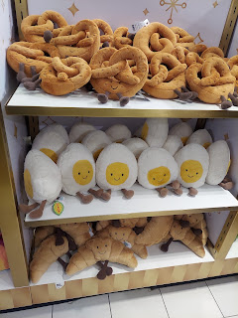

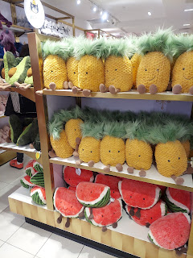

I can see now where the writers for the movie "Elf" got their ideas from . . . Gimble's Toy Store closely resembles FAO Schwarz. There are 3 levels to explore for the young and the old. You could spend waaay too much money here very easily . . .

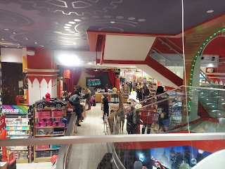

They even have an "adoption" nursery upstairs where you can choose your doll baby and go through the whole adoption process. It was nicely organized and laid out super cute!

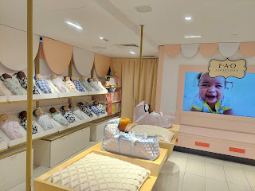

They also had several staff members sprinkled around the store to give you demonstrations for some of their products, including magic tricks to show you what their magic kit can do, and these glitter tattoos that Amber happily allowed the worker to apply on her hand. Their marketing ploy worked because Amber ended up buying some for the girls, ha ha.

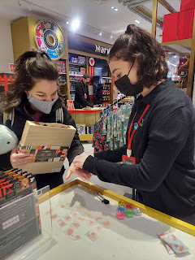

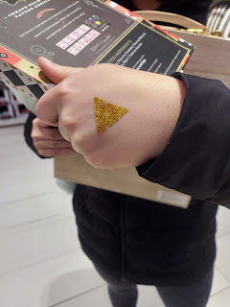

Upstairs, there is the famous "dance-on piano", which I was shocked to see that it was only $40!! If I could have taken it home with me on the plane, I absolutely would have!! They let you play on it, one family at a time. Here are a couple videos of the people before us and also Amber giving it a whirl.

#1: (22 seconds)

https://photos.app.goo.gl/Kr9nf4KiZzBjJCK26

#2: (Amber) (15 seconds)

https://photos.app.goo.gl/oBe43AwGBzPhM1ReA

After making our beloved purchases, we headed back to our hotel room to rest for a little bit. We decided to start calling it our "loft" instead of a hotel room. The rest time was not nearly long enough before we got back onto our very tired feet and headed to the subway yet again. This time, we headed south through several subway stops to go see  . . . the Blue Man Group!! They are so entertaining that we knew we wanted to go watch them in action, having bought our tickets a few weeks in advance.

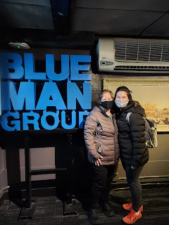

When we selected our seats online, we noticed that the first several rows were referred to as the "Poncho Zone". No thanks! We chose a row 3 rows behind the poncho zone and were quite happy with the view. It was a very small theater (Astor Place Theater), and even had a balcony above us.

You can see everyone in front of us putting on their ponchos before the performance started . . .

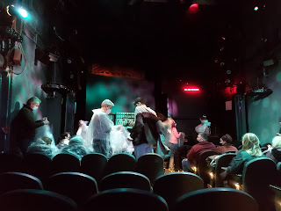

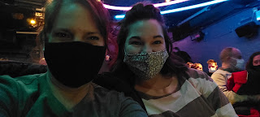

Unfortunately, we weren't allowed to take any photos or videos during the performance, but I did sneak in a photo at the very end when they were taking their bows. I figured that wouldn't be violating anything major . . .

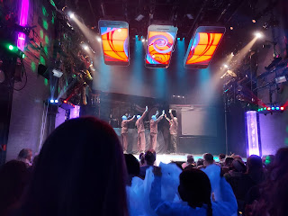

We had a BLAST though! We laughed and laughed and were thoroughly entertained. It was worth every penny!

The one thing that we found frustrating in NYC was getting food. While it's easy to go online before you head out and choose something that sounds good and has good ratings and is even nearby to where you'll be, it doesn't always turn out the way you planned. Sometimes the restaurant was further away than we thought and when our feet were hurting, we just didn't want to go any more out of the way. Sometimes the restaurant was actually closed when we arrived, even in the middle of the day! And sometimes it was just too tiny and there weren't any tables available, so if we ordered something we'd have to lug it all the way back to our "Loft". In those cases, we would start looking around desperately on the city block where we were, trying to find something else as a Plan B. And boy were there a lot of carbs in NYC. Pizza everywhere, burgers/fries, noodles and rice joints, etc. I wanted something tasty and healthy and hopefully lower in carbs, but I didn't always get those things. Sometimes I just had to settle for the sake of ease and convenience.

After the Blue Man Group was all done, we hunted for somewhere nearby where we could eat. We found this Asian restaurant and chose some noodle bowls. I was hoping that there would be lots of meat like the picture in the menu, but the meat bits were so tiny that I couldn't access them very well with chopsticks. They kept falling underneath all the noodles and drowning, ha ha. I had a spoon, but then I couldn't do much with the noodles . . . It was all a bit frustrating. And the red oily broth kept splattering onto my green shirt and my coat. Yes, I was still wearing my coat during dinner. We were both so cold that it seemed too much to unzip it and take it off. Now that I'm home, I hope that I can get the stains off the front of my clothes . . .

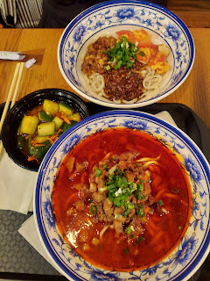

Winter Tip for NYC

: As long as you have mittens on (which we did), you can pick up some gelato and carry it all the way back to your "loft" without any of it melting. Because it's so freaking cold!!! ha ha

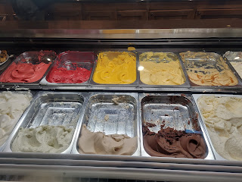

Sunday:

We had another good night of sleep and got up early to go to church. We had originally planned on going to a ward that met at noon, but then it became a logistical concern. We wanted to wear our Sunday clothes that we brought with us, but our choice of shoes would not be good for walking long distances. Then there was the matter of it being so FRIGID cold!! We knew we wanted to be able to change our clothes for the rest of the day and have more layers to keep us warm, so we changed tactics. We decided to get up early for a 9:00 Sacrament meeting and then come back to the loft to change into something more comfortable for the rest of the day.

It all worked out wonderfully. We went north again on the subway to the Central Park area, and attended church on the 3rd floor of the Manhattan Temple!! The speakers were wonderful and it was really special to partake of the Sacrament in such a beautiful setting.

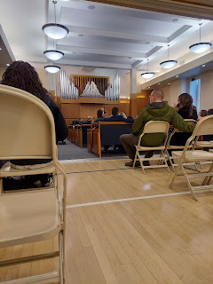

After the meeting was over, we made our way back to the subway station. That's when we noticed this street sign:

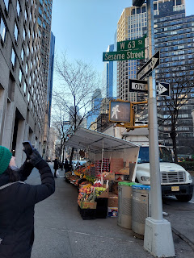

We searched on Google for where the Sesame Street show was actually produced. It said "123 Sesame Street" and told us which way to walk. But there was nothing there. While we had been humming, "Can you tell me how to get - how to get to Sesame Street", apparently Google could not get us there. How sad.

But this beautiful world globe was next to the entrance to the subway. So there's that!

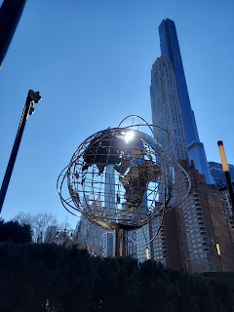

After changing our clothes, we made our way south - almost to the southernmost tip of Manhattan, and got off at the World Trade Center stop. Walking down Greenwich St. toward the 9/11 Memorial was a little eerie. Not only was it quiet because it was a Sunday morning and not as many people were out and about, but it was just a quieter section of Manhattan overall. Hardly a person passed by us. It allowed me to try to picture all the chaos and destruction of 9/11 a little more clearly, preparing me for visiting the Memorial itself.

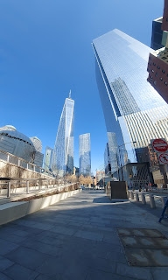

A beautiful mural (copper?) lined a building as we were heading toward the Memorial Pool on Greenwich St.

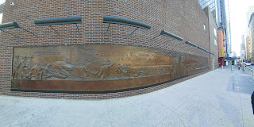

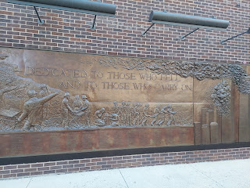

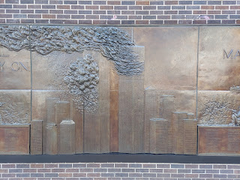

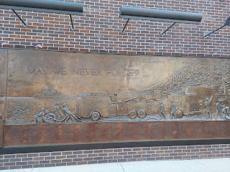

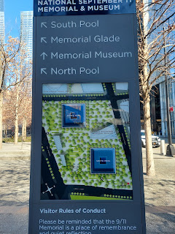

There were the occasional white roses inserted into someone's name engraved into the border around the Memorial Pool.

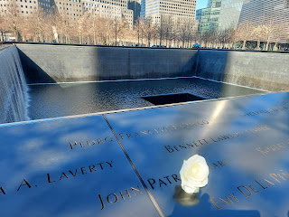

Video of the Pool: (17 seconds)

https://photos.app.goo.gl/Yqwq6uN97obdamtz9

Once inside, we headed down the escalator, passing these huge steel beams on the way . . .

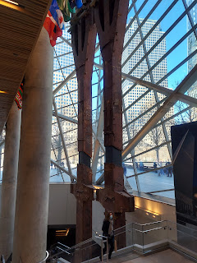

There were several structural "bones" of the building that are still standing. In many cases, families of the 9/11 victims petitioned to save them in honor of the fallen.

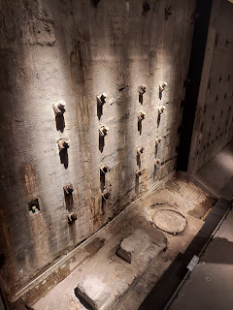

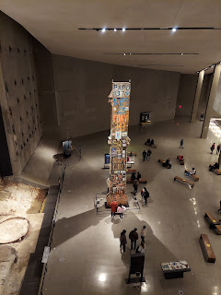

The Last Column: "As the recovery at the World Trade Center site neared completion, one piece of steel was chosen to mark the occasion symbolically. Designated the Last Column, it was removed from the site in a solemn ceremony held on May 30, 2002. In the weeks that preceded its departure, recovery workers, first responders, volunteers and victims' relatives signed the column and and affixed to it memorial messages, photographs and other tributes."

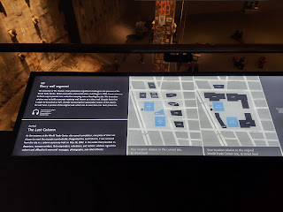

"Survivor Stairs"

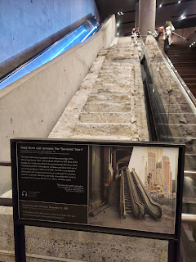

A beautiful wall with tiles to represent every single person that was killed on 9/11 and also in the WTC Bombing of 1993.

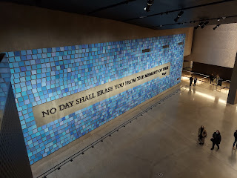

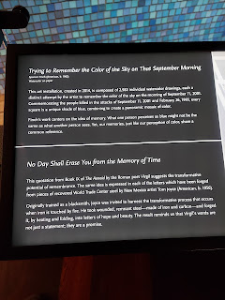

I particularly loved this wall of blue hues, meant to represent the possible hues of the sky on the morning of 9/11 before all the destruction began.

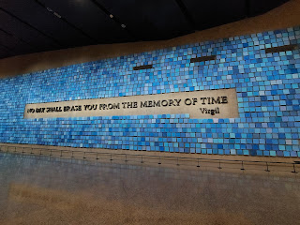

Lots of loving and artistic tributes on display -

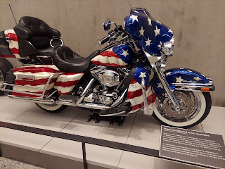

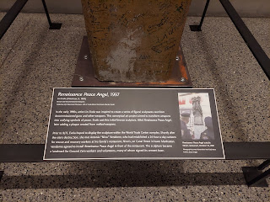

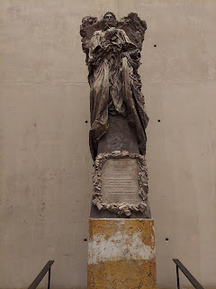

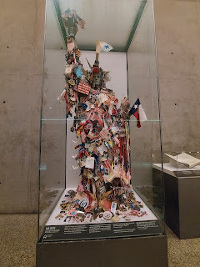

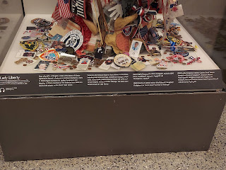

I thought this was so sweet and poignant - -

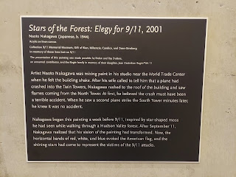

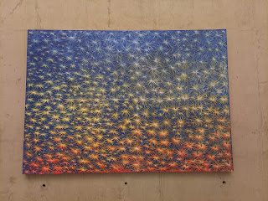

I took these photos because I knew my husband would appreciate the engineering marvel that the building was.

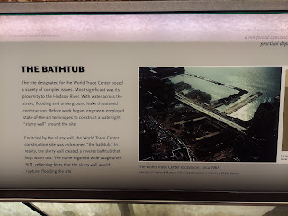

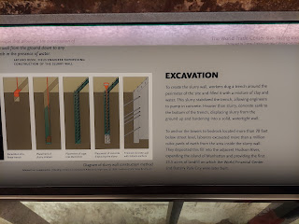

(Click the photos to enlarge them if you need bigger words - I know I would if I were the reader!)

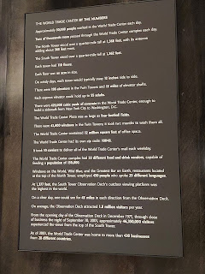

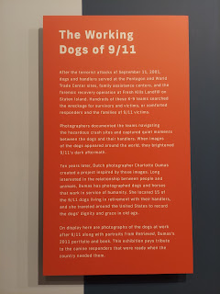

A few of the retired rescue dogs from 9/11. So sweet . . .

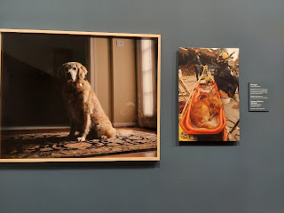

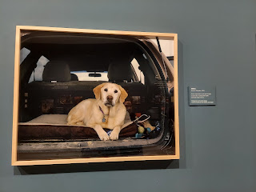

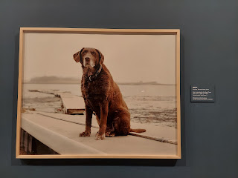

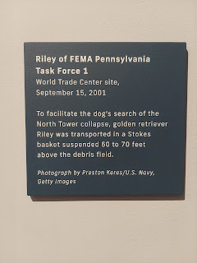

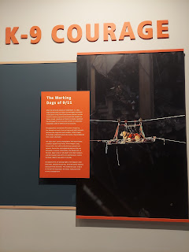

The FDNY lost SO many workers that day.

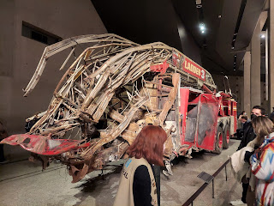

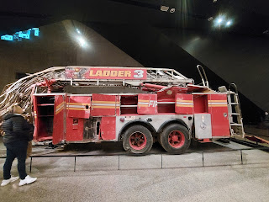

There were so many stories. And so many photographs to take in, at least one for each victim. But two stories really stood out to me.

1) A

window washer

was on his way up to clean windows when one of the hijacked planes hit the tower he was in. (I can't remember if it was the North or South Tower) The power went out and the elevator wasn't working. He had a bucket and a squeegee with him at the time and decided to use the squeegee to pry open and release the safety lock on the doors. They were extremely lucky to find sheetrock on the other side of the doors, instead of the expected concrete wall. Again, he and the others in the elevator, used that same squeegee to dig, scrape, and shovel a hole large enough for them to crawl through. On the other side, they found themselves in a women's bathroom. Someone was able to direct them to a nearby stairwell on the 50th floor and they all made it safely out of the building. The building collapsed a mere FOUR minutes later!! Unbelievable. His squeegee was in a display case in the Memorial Museum, but it was in an area where photographs were not allowed.

2) The

Red Bandanna Guy

. When one of the planes hit (can't remember which one), the lights went out on his floor and there was dust and debris all around. Nobody could see anything. His volunteer fireman instincts kicked into action and he reached into his desk to grab his red bandanna. He always kept a spare around for just such an occasion. He put it on his face and started trying to help others around him. He said, "If you can hear my voice, follow my instructions and I'll lead you to the stairwell." At one point he noticed an injured woman on the floor who couldn't get up and walk, so he did what firemen do. He picked her up and carried her all the way down the stairs himself. He went down enough flights of stairs to get to the 61st floor area, where emergency responders were already there and he could hand the woman off to them. As everyone was being directed down the next set of stairs, he turned the other way and went back up. He helped numbers of people get through the darkness and down to safety. Later, after the building had collapsed, no one could find the Red Bandanna Guy. It took some time before his body was recovered, still wearing the red bandana. He was only 24 years old.

The woman that was carried down to safety shared her story on the news, and a mother who was watching, instinctively knew it was her son that helped that lady. She was able to somehow contact the woman to show her a picture of her son. The injured woman verified that yes, it was her son that saved her life that day and many others as well.

A woman, the hero's sister, even made a book about the Red Bandanna Guy and I bought it in the 9/11 Gift Shop. It's called: "The Man in the Red Bandanna" by Honor Crowther Fagan, illustrated by John Crowther. Honor's brother was Welles Crowther, the hero and the Man in the Red Bandanna.

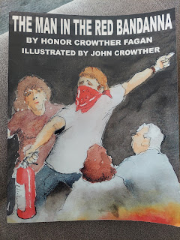

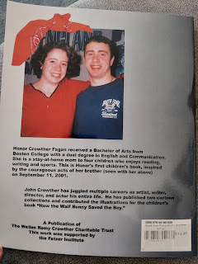

"Greater love hath no man than this, that a man lay down his life for his friends." John 15:13

Making our way toward the exit after an emotional 2 hours down below, we heard bagpipes playing . . . turns out that the bagpipes escorted us out via the sound system on our way up the very long escalator.

Listen carefully here: (9 seconds)

https://photos.app.goo.gl/26ivuKCs8nHySBhW7

We went through the gift shop and found a few meaningful items, knowing that the proceeds were going to a good cause. I bought a t-shirt that says "Love is stronger than Hate", a magnet that says "No day shall erase you from the memory of time", and a couple of books. I loved this flag on display in the gift shop, and is available for purchase. It lists the names of all the victims of 9/11 and the World Trade Center bombing (1993) to make up each of the stripes.

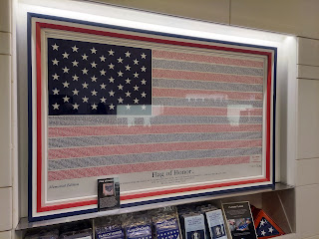

Outside and across the street is this beautiful structure, made to look like the wings of a dove.

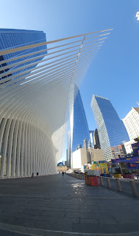

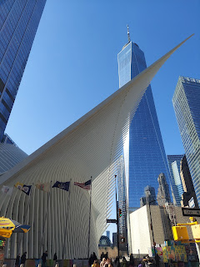

And this tiny little church, St. Paul's Chapel, constructed in 1766, somehow survived the destruction of 9/11 and became a haven for thousands of volunteers during the aftermath. We walked past it and I immediately felt extremely drawn to it and wanted to linger. But we had been fasting for the people of Ukraine for several hours and needed nourishment, so we moved along.

Here is a link to the story of the church: (and I remember seeing a book in the gift shop as well . . .)

https://www.911memorial.org/connect/blog/remembering-little-chapel-stood

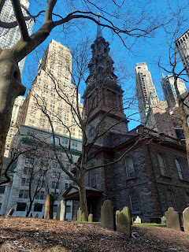

After our Plan A for lunch didn't work out, the Plan B turned out to be a nearby Vietnam restaurant. We got some really tasty Banh Mi sandwiches and a lemonade.

Next stop:

The Empire State Building

My overall impression of the Empire State was that it was significantly more touristy than our visit to the Rockefeller. The Empire State Building tour funneled us through exhibit after exhibit, showing us all the celebrities who have been there over the years, and you couldn't detour from any of the funneling. Stand in this line, move forward, go on this side of the hallway, get in this elevator, go through this 94th exhibit, etc. When we finally got up to the actual view and observatory, it was the same view as we had already seen at the Rock. Yes, it was super cool to stand where all the celebrities have also stood. And yes, the building itself was a marvel and was expertly built. And yes, the view was wonderful. But overall, I just didn't connect to it all very much. At least the Rockefeller was gorgeous in every way and on every floor. I think the best thing about being in the Empire State was that I had the opportunity to connect with the most epic scene in Sleepless in Seattle, one of my all time favorite movies. You know the scene. It's coming up below . . .

Here are some of the things we saw on our way to the top.

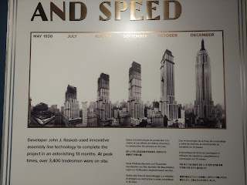

Short video of a whole room's representation of the time period when the building was being built: (23 seconds)

https://photos.app.goo.gl/Fh2Q3QEAMBTkXdr2A

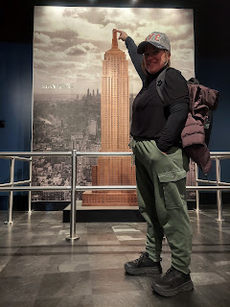

King Kong floor: (21 seconds)

https://photos.app.goo.gl/H4dwaJit8esNri3r7

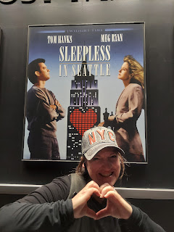

All the celebrities that have stood out on the observatory: (25 seconds)

https://photos.app.goo.gl/JFaHn9wfSA7N2fjk7

Up to the 80th floor . . .

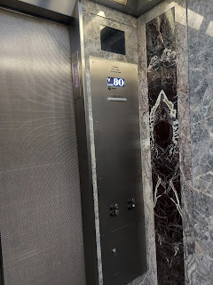

Ahh, finally the view of the city!

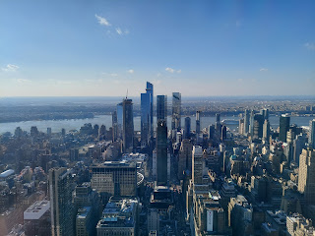

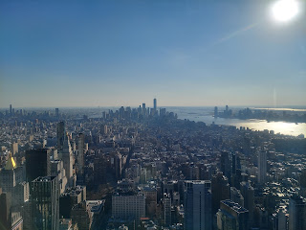

In one of the upstairs hallways, there was the most amazing tribute to this guy. He was given a 45 minute helicopter tour of Manhattan and was then invited to draw what he saw. Good thing he has a photographic memory! He is simply stunning and amazing!!

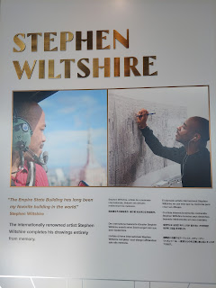

He drew all of this from memory over the course of the next 4 days. Wow.

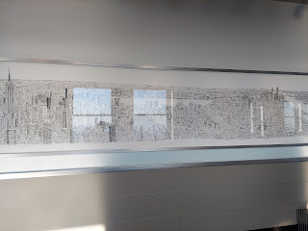

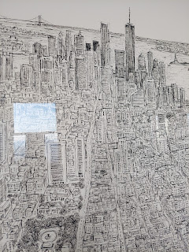

Even though this section was closed off, I still pictured that scene from Sleepless in Seattle, where the little boy of Tom Hanks was sitting there, waiting to meet Meg Ryan on Valentine's Day. He was so sure she would be the perfect match for his dad, and a wonderful new mom for himself.

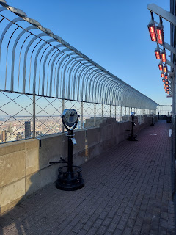

Video of being outside on the observation deck: (12 seconds)

https://photos.app.goo.gl/o1KzzEnm3WiafAFU7

Man, it was so windy! Before I stepped outside, one of the tour volunteers was practically insisting that I put my coat on. But I was so hot - I had worn way too many layers for the day and I was dying. I told the man, "I'm from Idaho where we understand what cold is. I promise I'll be fine." He said, "Ohh, Idaho. Well, okay then." (ha ha ha)

I really dislike this next photo because it makes me look like I'm super short and super wide, when in fact I'm just wearing multiple layers, I'm also carrying a backpack, and my coat is shoved in between my back and my backpack. Buuuut, I love that I'm there in that moment with my sweet daughter, Amber, who is always so smiley and fun.

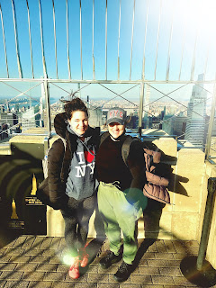

Another shot in the same place. Thank goodness for friendly tourists who are willing to trade taking pictures of each other. The photographer this time was a young man from Brazil who just moved to NYC 2 weeks ago for a new job.

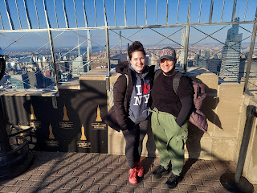

On our way back to the loft, we passed this guy on the street. We had passed him before, and Amber really wanted to buy one of his artistic subway maps, so we put it in reverse and went back to his little sidewalk "shop". Amber chose this one to take home and frame - and she was super happy with her purchase!! $20 for an original piece of art made by an artist originally from Kazakhstan. It even folds up nicely to go in your luggage! How convenient.

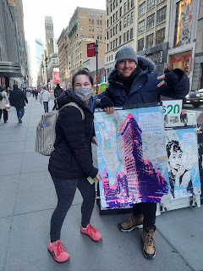

After changing my clothes for the 3rd time that day (ha ha), I was finally in something comfy and with more appropriate layers to go on our last hurrah in NYC. We walked a few minutes down 42nd Street to the west, headed toward Pier 83 for our evening cruise around Manhattan. I had read online that it was a beautiful and memorable experience, some even saying that it was the highlight of their entire visit to NYC!

We chose to do the Harbor Lights Cruise through Circle Line. It was a great way to end the weekend together.

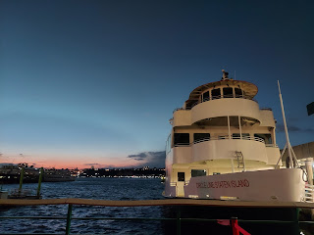

Even though it was very windy and cold, we could choose to sit indoors where it was warm and protected from the wind, or we could go up to the outdoor deck at any point and sit up there. We chose to start out indoors and wait until we were closer to the Statue of Liberty to go upstairs. Good choice!

This was the Hoboken and Jersey City skyline across the Hudson River looking toward New Jersey. Very pretty.

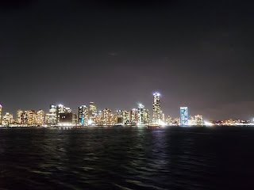

Ellis Island

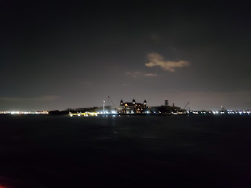

The Beautiful Lady Liberty - (16 seconds)

https://photos.app.goo.gl/2936SXd7gNm1zGd26

*Note: I swear it looked like there was a person in the water, wearing a flashing light on their helmet . . . but a friend said last night, "Um, I think that's just a buoy . . ." ha ha ha

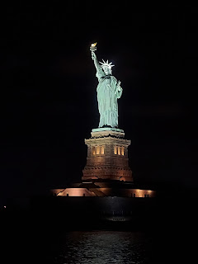

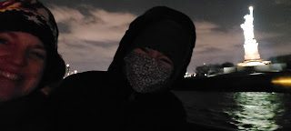

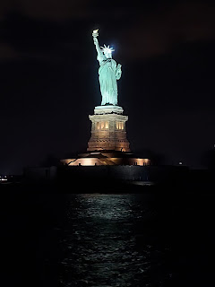

Soon, we came up around the horn and passed underneath the Brooklyn Bridge.

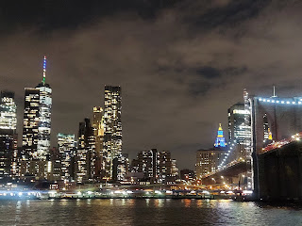

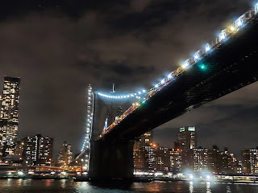

Then underneath the Manhattan Bridge . . .

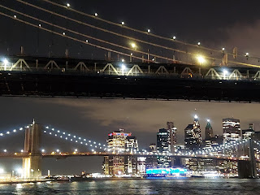

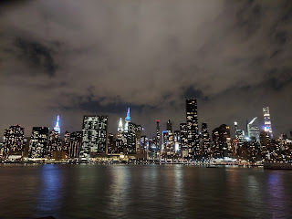

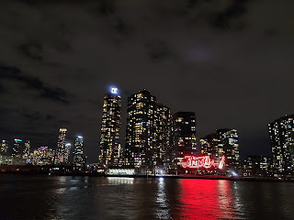

A panoramic view as we turned around to head back

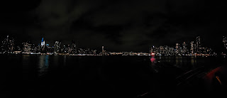

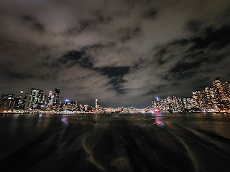

Sorry this next photo is slightly blurry, but the narrator of the tour pointed out that the tower in the middle, kind of the middle right, is lit up with blue and yellow. This was one way that NYC showed the world that they supported and were unified with Ukraine. How lovely. :)

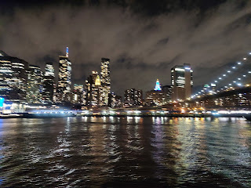

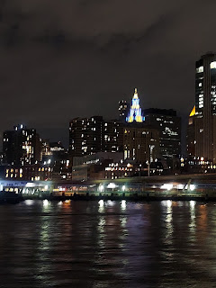

The narrator of the tour, whose name was Andy, was SO GREAT!! He not only had a great sense of humor, but he was profoundly gifted with his knowledge of the history, fun facts, and statistics of NYC. He would casually walk around on the different levels of the boat, holding the microphone in one hand, gesturing with his other hand as he talked, but very clearly this was all in his memory! He was not reading a script of any kind. He knew it all and remembered it all! Amazing. He looked to be in his early 60's or so. He narrated for most of the 2 hour tour, and we enjoyed it all very much.

One of the things he pointed out to us was that 42nd Street is the only street where you can see from the Hudson River all the way to the East River - unobstructed. And it was true! We sailed from 42nd Street at Pier 83 all the way around to 42nd Street on the East River and back. When Amber and I disembarked, this was the first photo we wanted to get: the view looking east down 42nd Street. Who knew that our loft was on this same street the whole time!! So cool. (We stayed at the POD Times Square Hotel by the way)

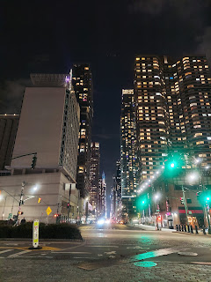

I researched while we were on the boat for where we could get a late dinner once we were done. There was a nearby Irish restaurant called Landmark Tavern that had really good ratings and it was open until 10:00. When our boat returned to the dock at 9:00 p.m., we headed right over.

During the short walk, we passed this huge naval ship, "Intrepid".

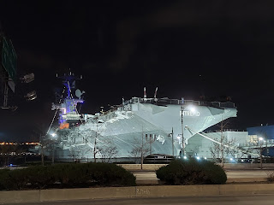

I didn't know the significance of it at the time, but it sure was large and majestic! Later I learned that we walked past the Sea, Air & Space Museum, which included the USS Intrepid. From their website: "Launched in 1943, the aircraft carrier

Intrepid

fought in WWII, surviving five kamikaze attacks and one torpedo strike. The ship later served in the Cold War and the Vietnam War.

Intrepid

also served as a NASA recovery vessel in the 1960's." SO COOL!!

We were the only customers in the restaurant that late at night, so we got the royal treatment. And it turned out that this restaurant is the 2nd oldest Irish Pub in NYC - it is now

151 years old

!! Very cool. The food was fantastic, too, which was nice since we were pretty hungry.

I ordered the potato leek soup.

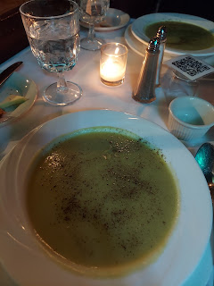

And pan seared shrimp over arugula and feta cheese - super delicious!

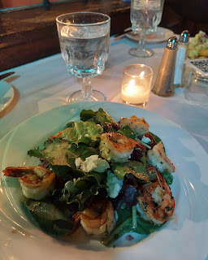

This was finally the perfect meal in NYC: not too crowded, not too expensive, it actually had tables to sit down, and was close to where we were. Amazing.

Monday:

We had another good night of sleep in NYC which was great. We got ready quickly and out the door. We grabbed a banana next door at the little grocery store and mailed a package at the UPS store a couple blocks away before checking out of the hotel. Then it was time for our last subway experience. I wasn't sorry - if I'm being honest. It's fine to use the subway system for a short burst, like a weekend, but I don't think I would enjoy having to use it every single day for years.

We transferred to a bus that took us directly to our terminal at LaGuardia, and after getting through security and finding some food, we sat down to eat for a few minutes at my gate together. Too soon, it was time to get in line to board my flight, which left 1.5 hours ahead of Amber's flight.

One last (and long) hug.

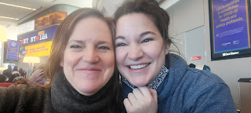

I will miss that sweet girl of mine. Thankfully I'll get to see her whole family in April though, when I fly down to Louisiana to babysit Abby and Gwen while their parents go on a cruise together.

We both made it home to our families late Monday night and all is well. :)

WOW! Congratulations!

You made it this far. Unbelievable. If you're interested in reading about the first part of last week BEFORE our amazing trip to NYC, then carry on.

Last Monday (President's Day):

Scott and I rolled up our sleeves and accomplished a major feat - cleaning out the upstairs office!! While he went outside and unburied the entire neighborhood from the few inches of snow that fell overnight, I started working on the office (particularly my own desk).

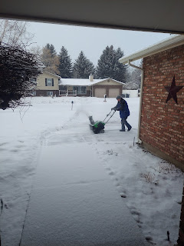

Before:

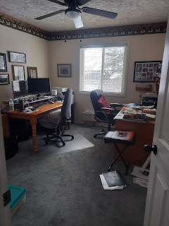

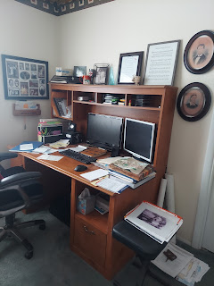

The desk, once cleaned out, was moved to the garage and listed on Facebook Marketplace. It was sold by the very next day. Wonderful!

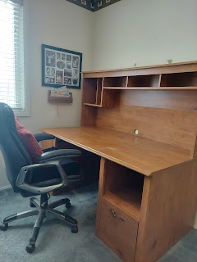

After: (very basic and simple, but using tables and filing cabinets we already had)

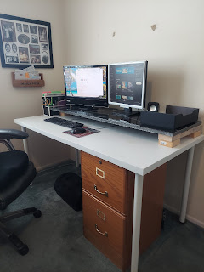

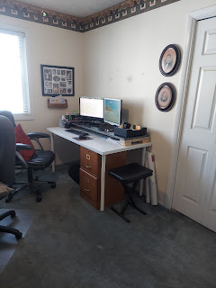

The office is much more open and inviting now, without all the clutter . . .

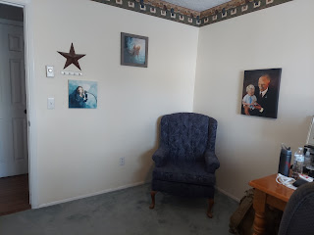

Scott still has some tidying to do on his own desk though . . .

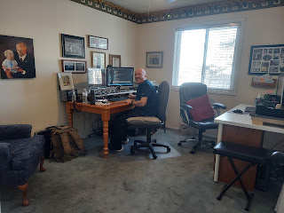

We ordered a new flag for the front of the house to replace the raggedy old one we've had for some time. The old one was ready to be "retired". I find it weird that burning a flag is one of the acceptable methods of getting rid of it. But I suppose that's better than throwing it in a dumpster.

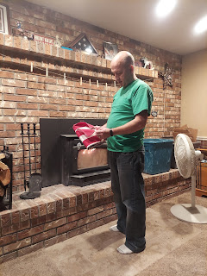

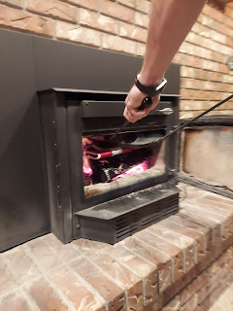

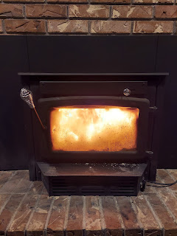

Tuesday:

I had a little video chat with these two cuties over in Italy. Avery is getting so big!! She's so chatty and darling and cute and happy! (At least when I get to see her, ha ha.) I can't wait to meet her in person!!

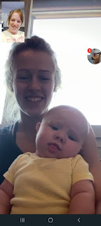

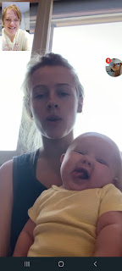

Here is another cuter-than-cute video of Avery just talking up a storm: (42 seconds)

https://photos.app.goo.gl/BSSZbsd3zXFC9iCPA

Later that night I set up the kitchen and dining room for a painting activity with my young women class. They had a lot of fun!!

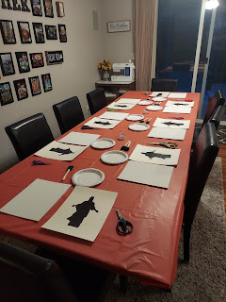

I had them cut out a silhouette of Jesus from the cardstock and tape Him onto an 8x10 canvas.

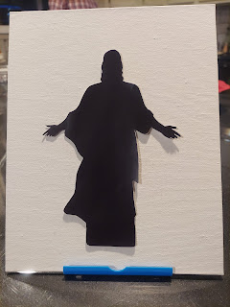

Then they gently used a foam brush to paint outward from Jesus (in order to not get blobs of paint underneath the silhouette). Once they were done, they could peel up the silhouette and Voila! A beautiful piece of art to display in their bedrooms.

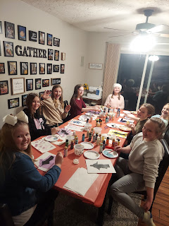

One of the girls decided she wanted to do something different. And that's okay. :)

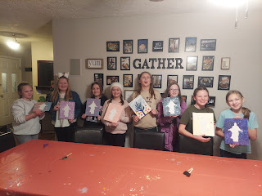

Wednesday:

All I did was hurry, hurry, hurry . . . and pack, pack, pack so I could be ready for early the next morning.

I do, however, have a few last photos of grandbabies to share. Jack just loooves his food and gets so happy when it's time to eat. Look at where his focus is in the next photo, ha ha.

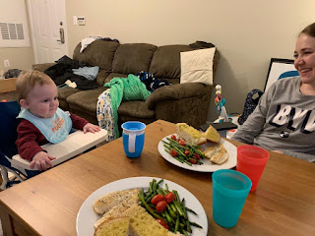

And Jacob sent us this one in our group chat, entitled, "Target Baby". Scott responded with, "That's how I feel in Target, too!"

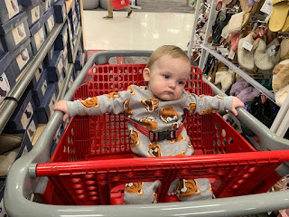

Abby is sure growing up, too. She'll be seven in less than a month!!

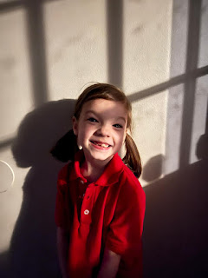

And they have a new member of the family down in Louisiana: his name is Goose. He is very shy and just hides most of the time.

